
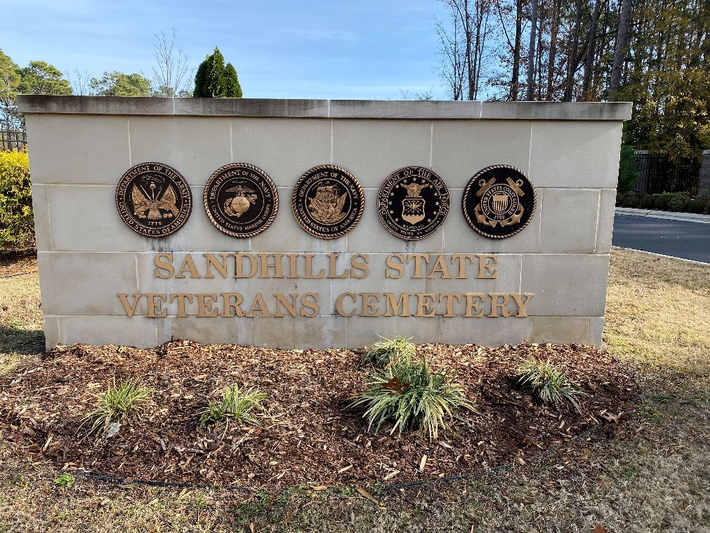

Location Information
Sandhills State Veterans Cemetery (NCSVSL)
400 Murchison Road
Spring Lake, NC 28390
Veteran Graves: 9,003
Coverage Goal: 9,003
Ceremony On: Saturday, December 13, 2025
Ceremony At: 12:00 PM
Location Coordinator: Ann Provencher, (910) 670-9280, ann3989@yahoo.com

